Edward Hill

CTEC 298

4/7/2023

PART 2 PYTHON

**CONDITIONS:**

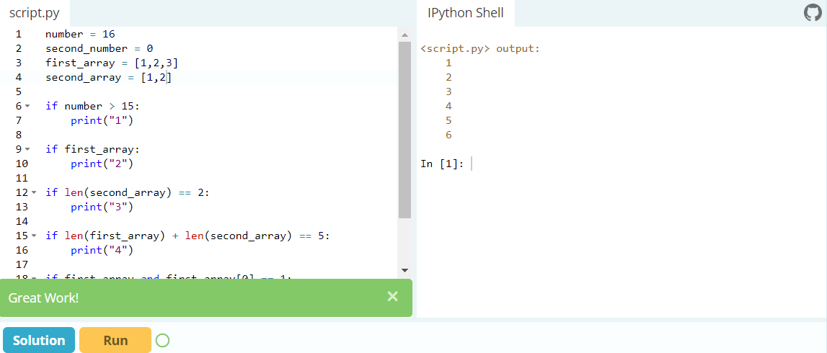

**LOOPS:**

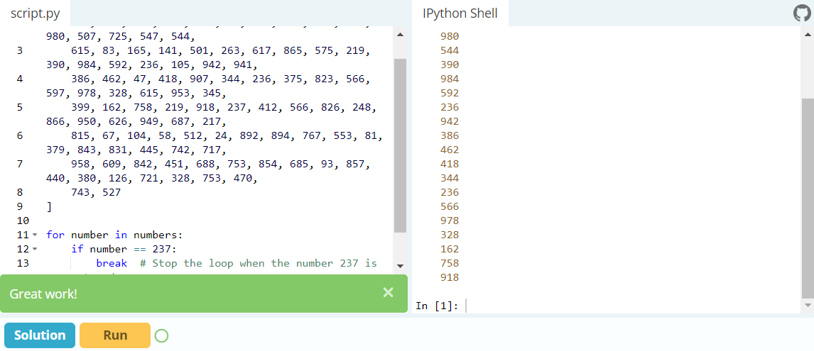

**FUNCTIONS:**

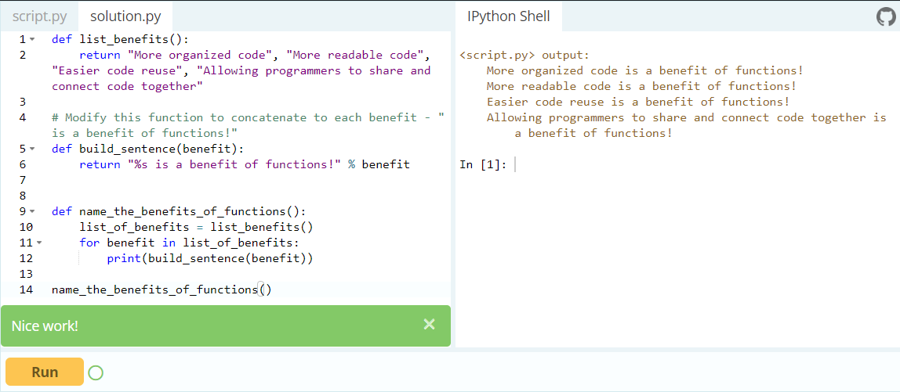

**CLASSES AND OBJECTS:**

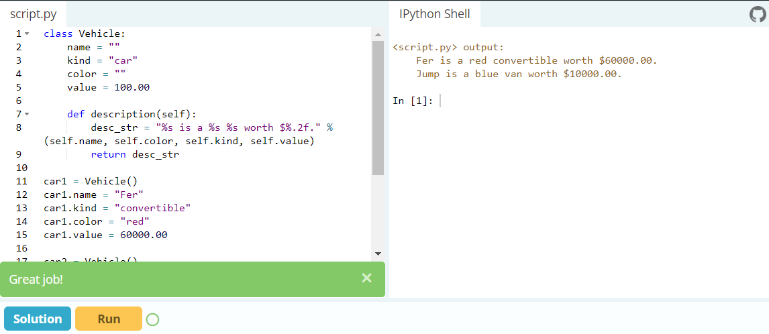

**DICTIONARIES:**

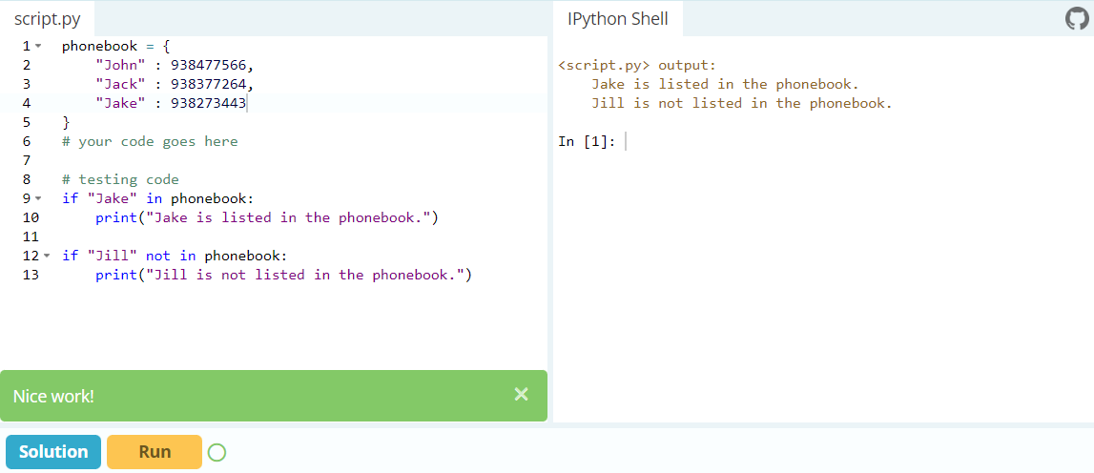

**MODULES AND PACKAGES:**

